Debra Kernstock

November 10, 2018

Lab 5

Part 1

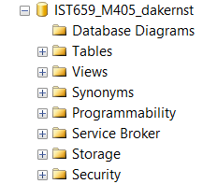

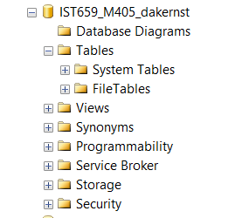

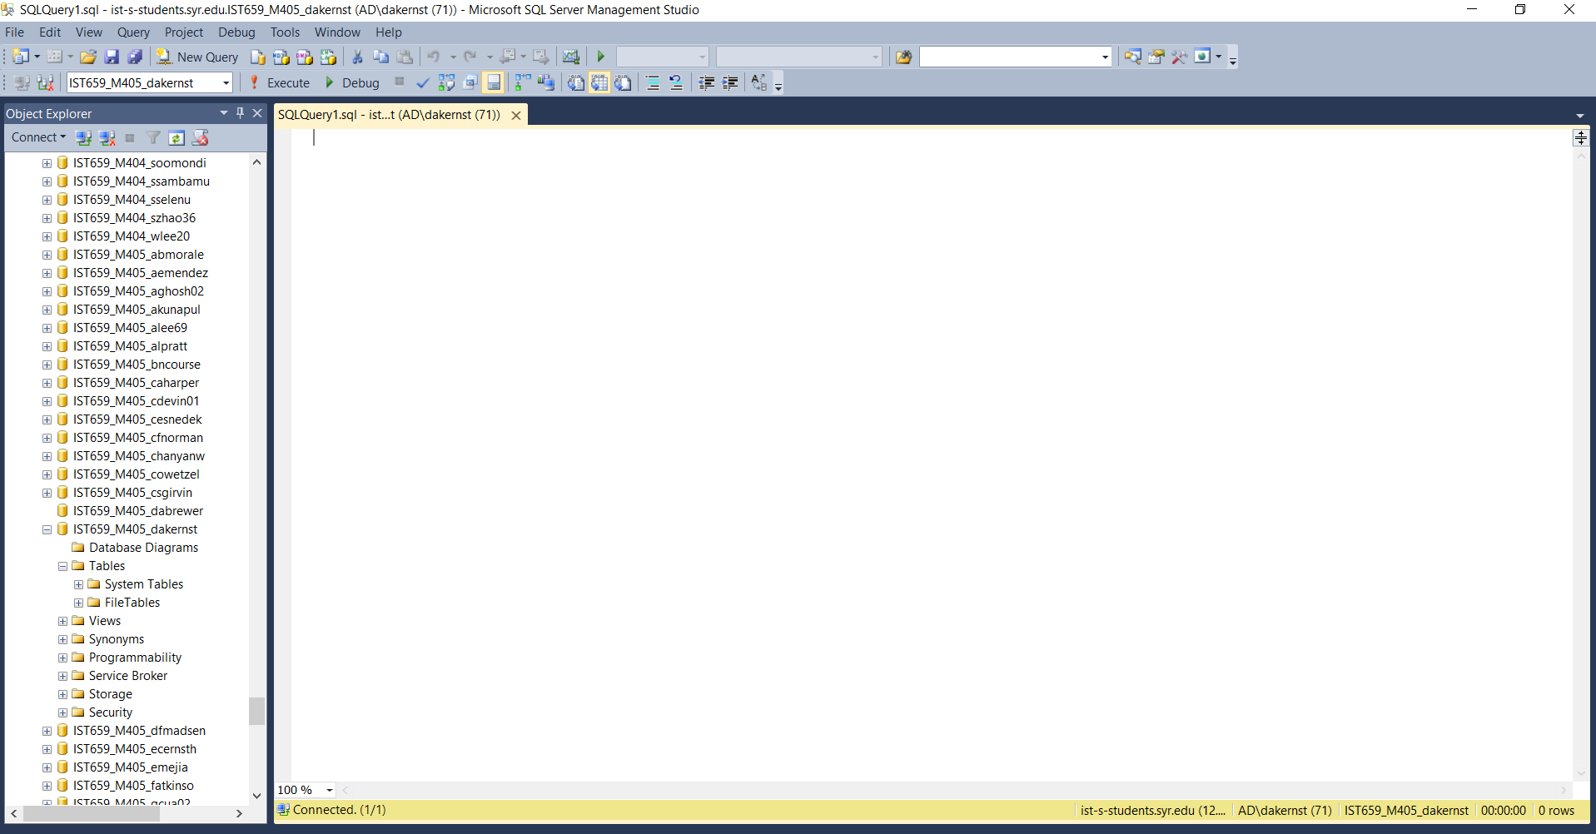



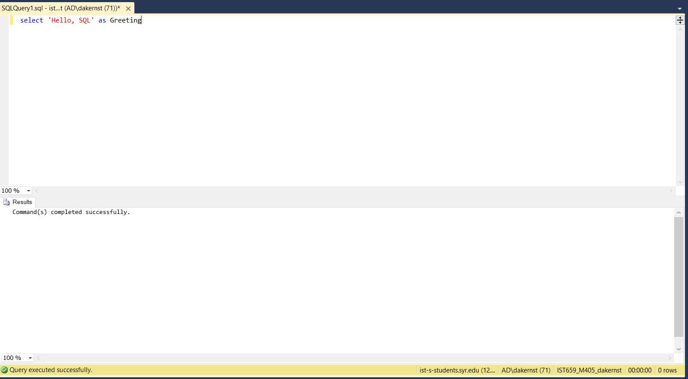

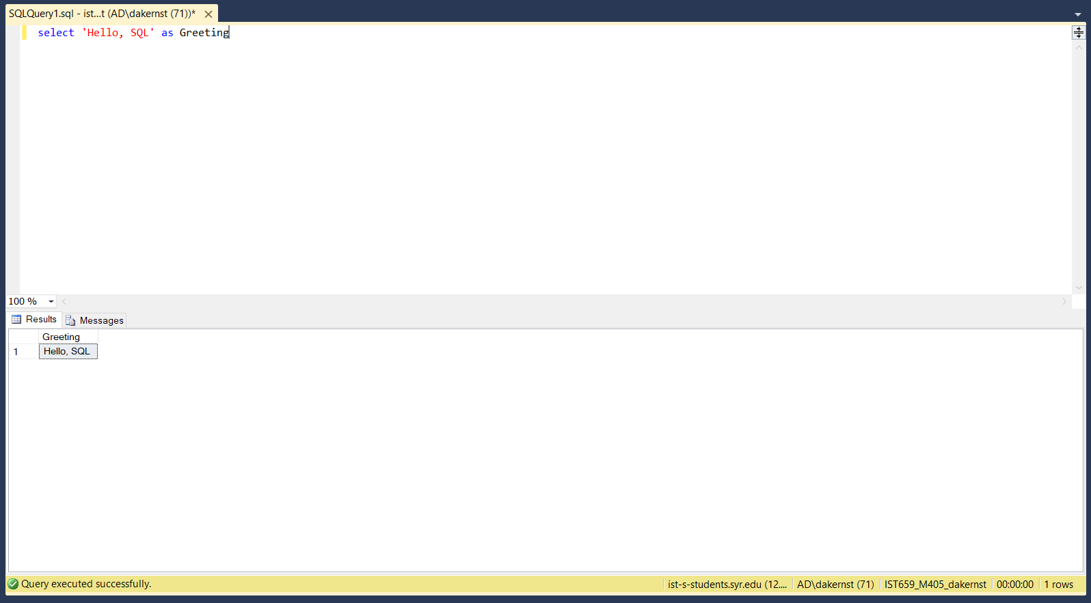

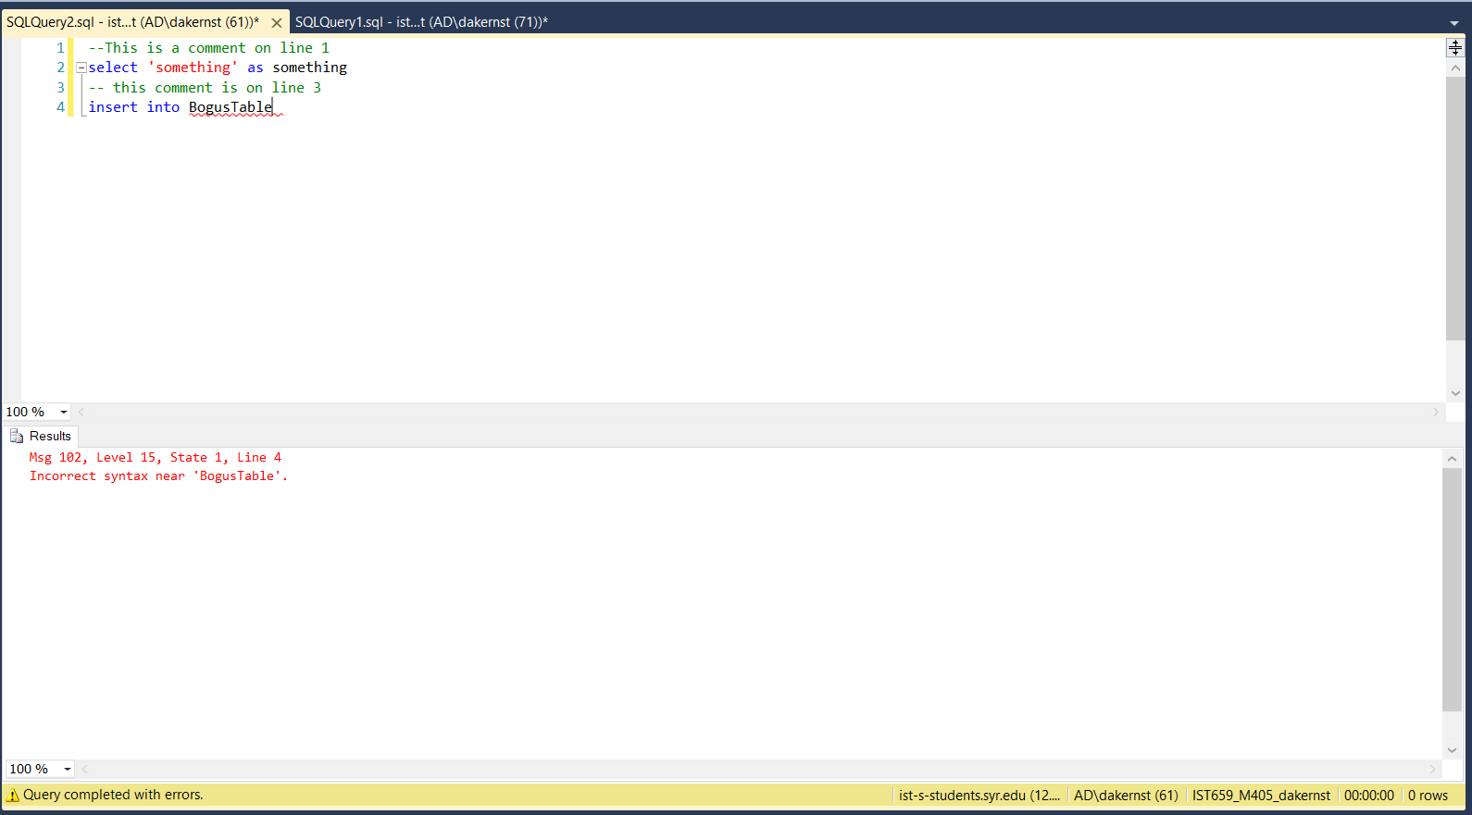

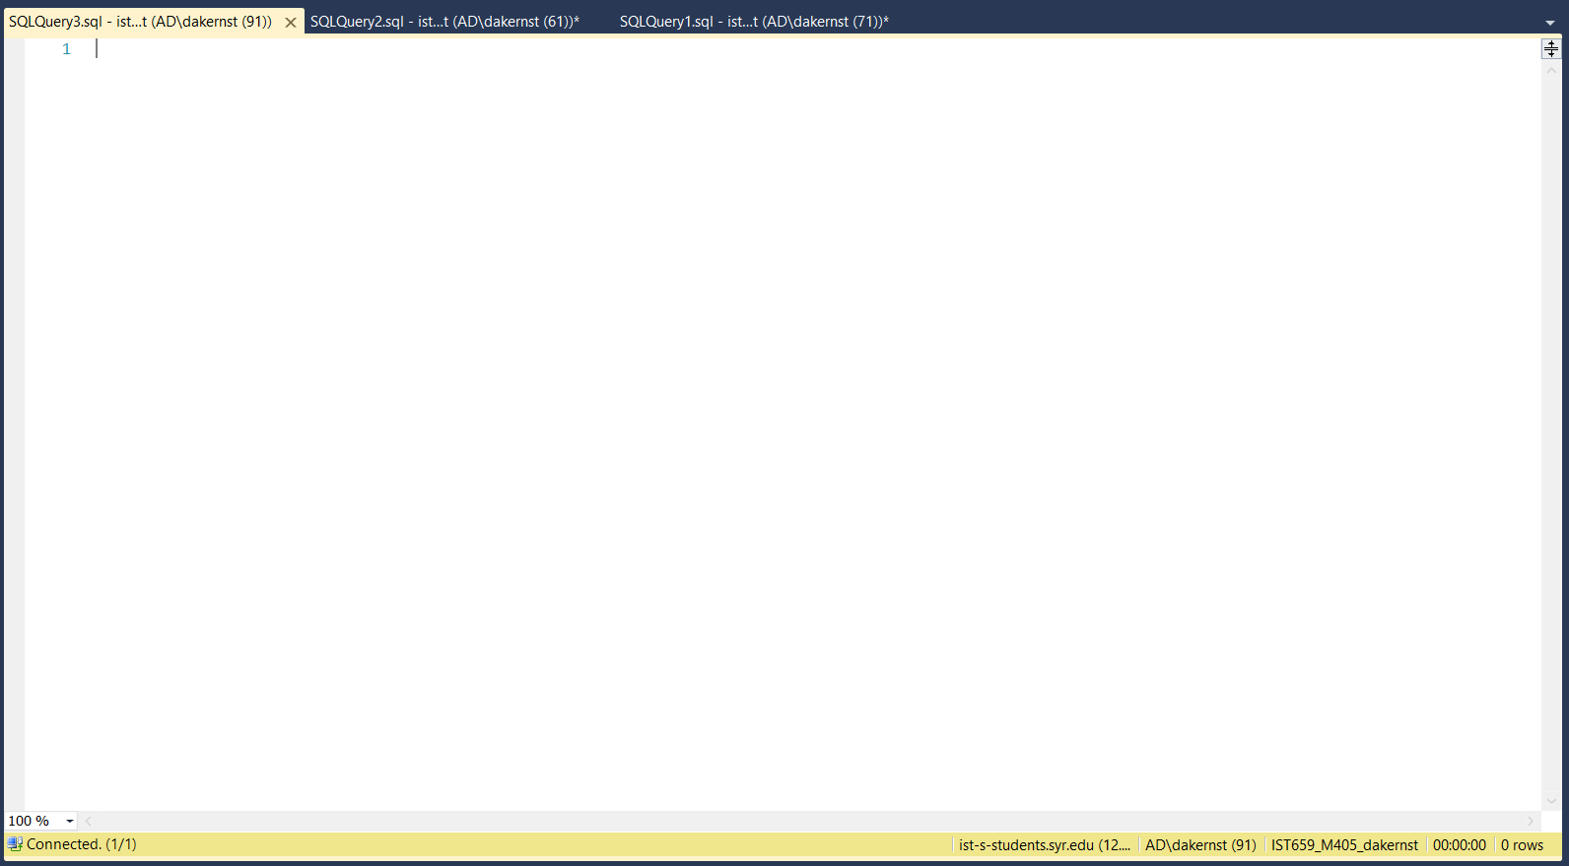

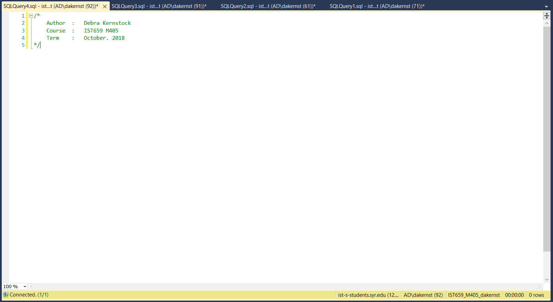

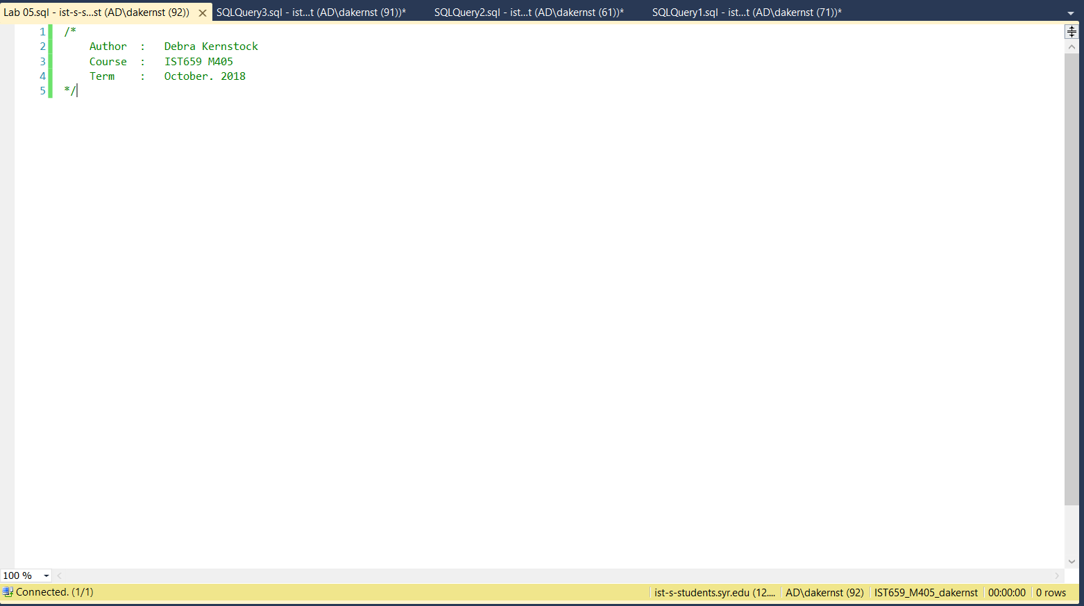

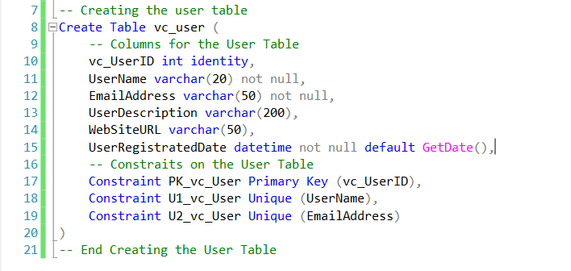

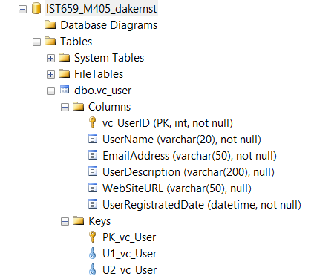

User Table

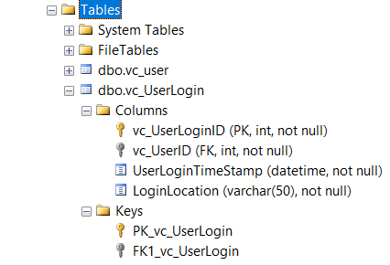

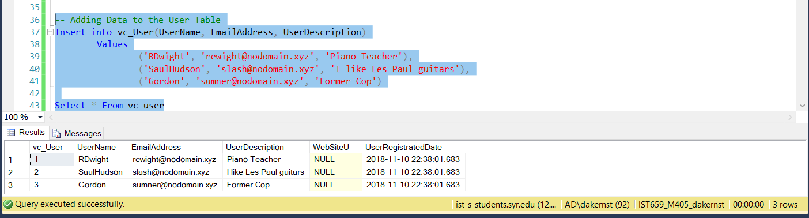

User Records

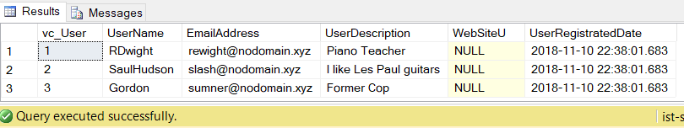

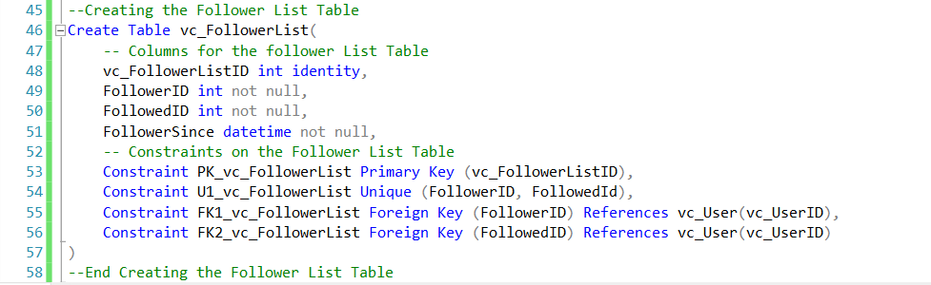

User Tables

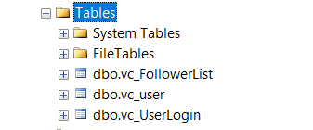

Part 2

VidCast tables

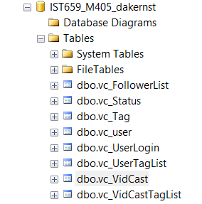

/*

Author : Debra Kernstock

Course : IST659 M405

Term : October. 2018

*/

-- Creating the user table

Create Table vc_user (

-- Columns for the User Table

vc_UserID int identity,

UserName varchar(20) not null,

EmailAddress varchar(50) not null,

UserDescription varchar(200),

WebSiteURL varchar(50),

UserRegistratedDate datetime not null default GetDate(),

-- Constraits on the User Table

Constraint PK_vc_User Primary Key (vc_UserID),

Constraint U1_vc_User Unique (UserName),

Constraint U2_vc_User Unique (EmailAddress)

)

-- End Creating the User Table

--Creating the UserLogin table

Create Table vc_UserLogin (

-- Columns for the UserLogin table

vc_UserLoginID int identity,

vc_UserID int not null,

UserLoginTimeStamp datetime not null default GetDate(),

LoginLocation varchar(50) not null,

-- Constraints on the User Login Table

Constraint PK_vc_UserLogin Primary Key (vc_UserLoginID),

Constraint FK1_vc_UserLogin Foreign Key (vc_UserID) References vc_User(vc_UserID)

)

--End Creating the User Login Table

-- Adding Data to the User Table

Insert into vc_User(UserName, EmailAddress, UserDescription)

Values

('RDwight', 'rewight@nodomain.xyz', 'Piano Teacher'),

('SaulHudson', 'slash@nodomain.xyz', 'I like Les Paul guitars'),

('Gordon', 'sumner@nodomain.xyz', 'Former Cop')

Select * From vc_user

--Creating the Follower List Table

Create Table vc_FollowerList(

-- Columns for the follower List Table

vc_FollowerListID int identity,

FollowerID int not null,

FollowedID int not null,

FollowerSince datetime not null,

-- Constraints on the Follower List Table

Constraint PK_vc_FollowerList Primary Key (vc_FollowerListID),

Constraint U1_vc_FollowerList Unique (FollowerID, FollowedId),

Constraint FK1_vc_FollowerList Foreign Key (FollowerID) References vc_User(vc_UserID),

Constraint FK2_vc_FollowerList Foreign Key (FollowedID) References vc_User(vc_UserID)

)

--End Creating the Follower List Table

-- Creating the Tag Table

Create Table vc_Tag(

-- Columns for the Tag Table

vc_TagID int identity,

TagText varchar(20) not null,

TagDescription varchar(100)

-- Constraints on the Follower List Table

Constraint PK_vc_Tag Primary Key (vc_TagID),

Constraint U1_TagText Unique (TagText)

)

-- End Creating the Tag Table

-- Creating the Status Table

Create Table vc_Status(

-- Columns for the Status Table

vc_StatusID int identity,

statusText varchar(20)

-- Constraints on the Status Table

Constraint PK_vc_status Primary Key (vc_StatusID),

Constraint U1_StatusText Unique (StatusText)

)

-- End Creating the Status Table

-- Creating the VidCast Table

Create Table vc_VidCast(

-- Columns for the VidCast Table

vc_VidCastID int identity not null,

VidCastTitle varchar(50) not null,

StartDateTime datetime,

EndDateTime datetime,

ScheduledDurationMinutes int,

RecordingURL varchar(50),

vc_UserId int not null,

vc_StatusID int not null

-- Constraints on the VidCast Table

Constraint PK_vc_VidCast Primary Key (vc_VidCastID),

Constraint FK1_vc_VidCast Foreign Key (vc_UserID) References vc_User(vc_UserID),

Constraint FK2_vc_VidCast Foreign Key (vc_StatusID) References vc_Status(vc_StatusID)

)

-- End Creating the VidCast Table

-- Creatng the VidCast Tag List Table

Create Table vc_VidCastTagList(

-- Columns for the VidCast Tag List

vc_VidCastTagListID int identity not null,

vc_TagID int not null,

vc_VidCastID int not null

-- Constraints on the VidCast Tag List Table

Constraint PK_vc_VidCastTagList Primary Key (vc_VidCastTagListID),

Constraint U1_vc_VidCastTagList Unique (vc_TagID, vc_VidCastID),

Constraint FK1_vc_VidCastTagList Foreign Key (vc_TagID) References vc_Tag(vc_TagID),

Constraint FK2_vc_VidCastTagList Foreign Key (vc_VidCastID) References vc_VidCast(vc_VidCastID)

)

-- Ending Creating VidCast Tag List

-- Creating the User Tag List Table

Create Table vc_UserTagList(

-- Columns for the User Tag List Table

vc_UserTagListID int identity not null,

vc_TagID int not null,

vc_UserID int not null

-- Constraints on the User Tag List

Constraint PK_vc_UserTagList Primary Key (vc_UserTagListID),

Constraint U1_vc_UserTagList Unique (vc_TagID, vc_UserID),

Constraint FK1_vc_UserTagList Foreign Key (vc_TagID) References vc_Tag(vc_TagID),

Constraint FK2_vc_UserTagList Foreign Key (vc_UserID) References vc_User(vc_UserID)

)

-- Ending Creating User Tag List Table